**Coursera Capstone – Coffeeshop in London**

**Business Problem**

This project will focus on where to open a new coffeeshop in London. Since this report is tailored for a new coffeeshop for a new entrepreneur, the report will attempt to focus on business districts that have not yet been overexposed in terms of available coffeeshops and specifically new up and coming business districts in the city of London.

The research will first focus on where new businesses are setting up their offices under the assumption that unlike several large business locations such as Canary Wharf, the areas that will be considered in this report will not have many coffeeshops already open or there will still exist a market gap between demand and supply.

New business districts will be exploted and the data science methodology learned throughout the course will be used to attempt to find the best possible district.

**Data**

The final decision will be based on a number of factors including:

*Distance from major underground locations

*Number of nearby coffeeshops

*Nearby shop types

The data sources to be used will be

* using google geocoding to retrieve the respective longitude and latitude coordinates

* foursquare to get all nearby coffeeshops

**Methodology**

Since London is a major city that will have its own incredible range of coffee shops, it made little sense to focus on the entire city. Some research was done to discover new up and coming areas in the city where a growing number of businesses and hence population or visitors during the day would suggest the coffee shop market could increase in the future. The neighborhood of Hackney was selected.

One of the assumptions undertaken was that people mostly use the undgerground to travel to and from the workplace hence the main geopoint would be the underground of the location selected. Hackney Central would be the underground used for this project.

With a radius of 1000, foursquare was used to find the most prominent coffee shops in the area.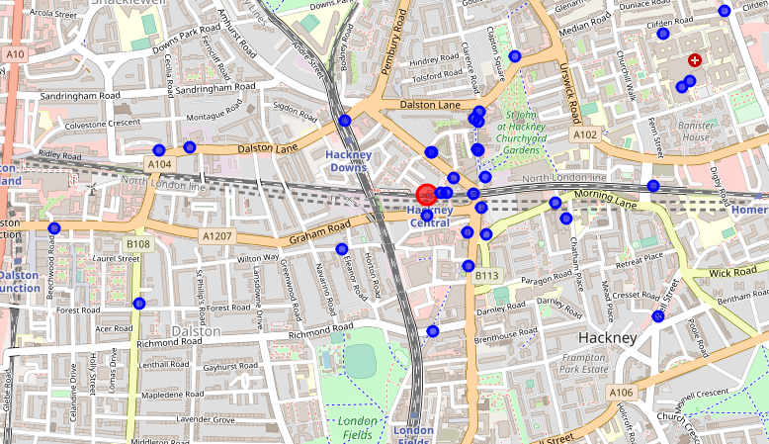

Clusters would then be used to navigate through the area and find what type of businesses are open next to these shops and whether assuming these are the current major regions where people would go out in the area.

**Results**

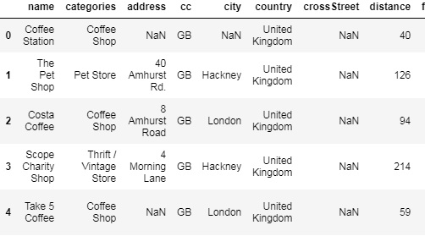

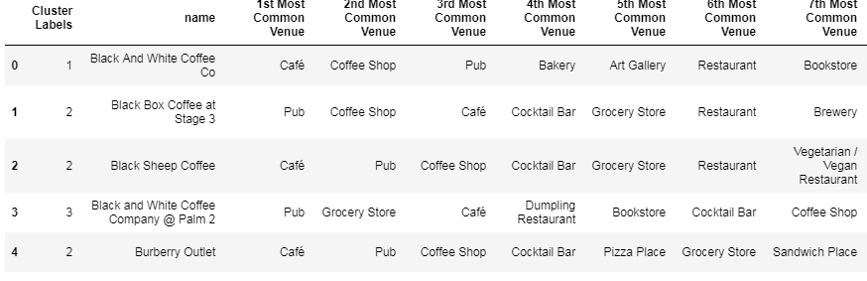

First cluster

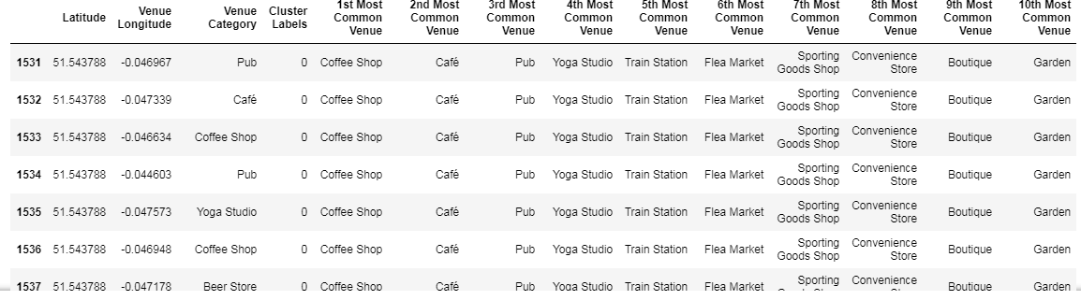

Second cluster

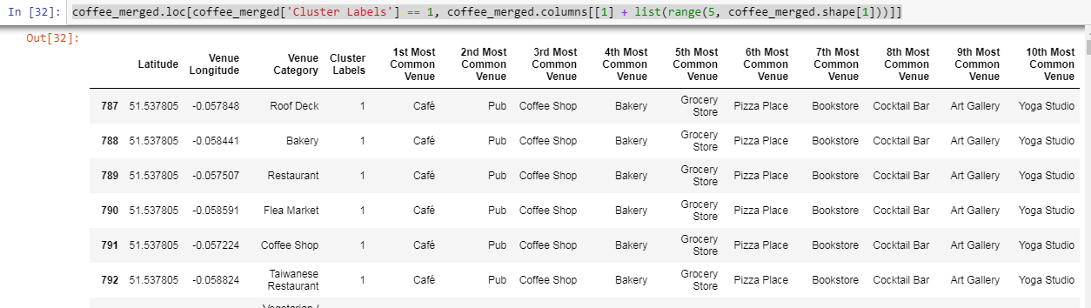

Third cluster

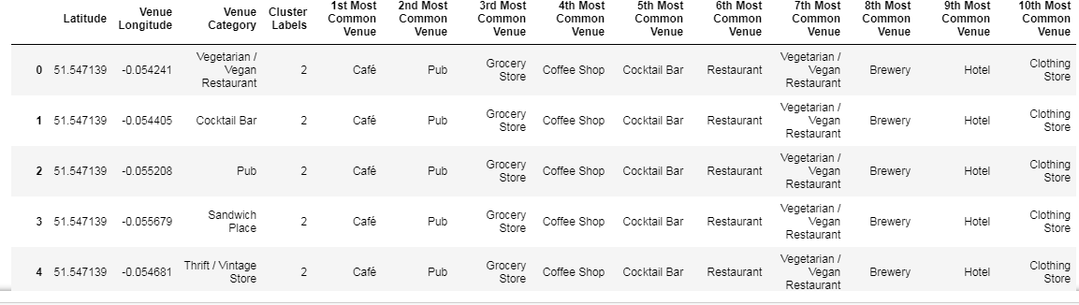

Fourth cluster

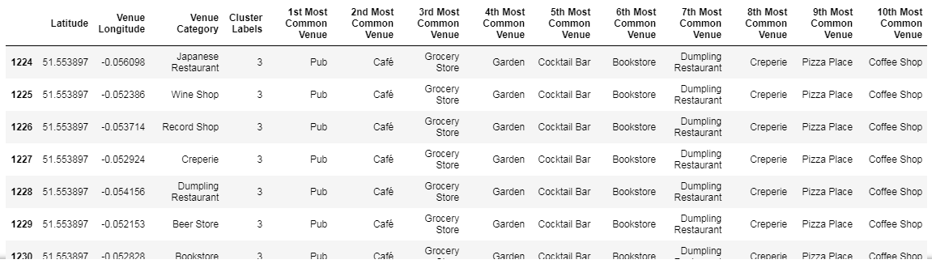

Fifth cluster

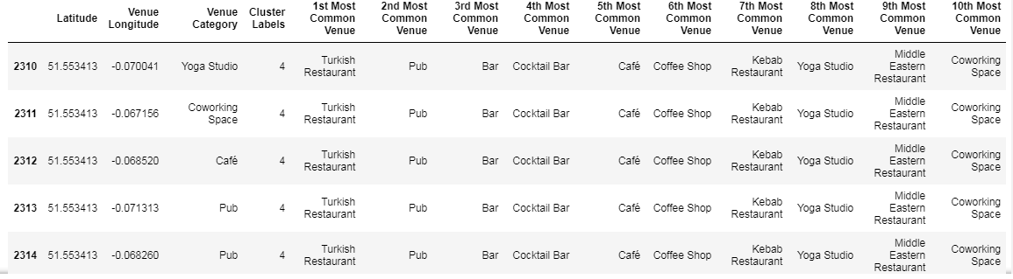

**Discussion & Conclusion**

The results seem to show two main points, with just one of the clusters listing the underground station as the most common nearby place and it was not in the 1st most common shows there could be the potential to open very close to the station, in the attempt that this is one of the up and coming areas in London this underground station should experience a significantly higher traffic that would allow for a closeby coffeeshop to come in and do business.

Of the clusters, many of the locations seem to not exclusively be coffee shops, the main category of store being considered for this project. This in itself would also seem to conclude that there is room for a new premium coffee shop location to open up.

This all depends on the accuracy as well as the assumption that this location will be growing in the future. Further analysis to be done includes what major types of businesses are opening and where those locations are of these businesses. The style of the businesses would link to the nature of the types of employees and would help distinguish pricing schemes and themes for the coffee shop.

This has been a pleasure to attempt this first ever data science project.

**References:**

Foursquare.com

Coursera.org IBM Data Science Professional Certificate

<https://jamesanderson.co.uk/news/top-5-coming-london-areas-2018/>